Here is how to update to the new wallet.

On windows

Exit the wallet

go to C:/user/Appdata/roaming/sanchezium and save the selected files and folders, everything else needs to be deleted.

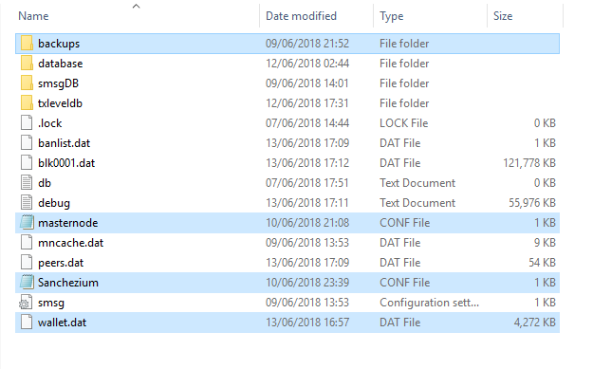

Once this is completed download the bootstrap file and add it to the same directory.

<http://sanchezium.com/downloads/bootstrap.dat>

restart your wallet and welcome to the new chain.

On VPS

Stop daemon

Delete the old wallet from the directory you have previously installed.

Locate your .Sanchezium directory, which holds your wallet.dat, normally in root or in the user directory

And save only the selected items as shown in picture above.

Add the bootstrap file.

Start the daemon and welcome to the new chain.